**Name**: Samya Sunibir Das

**ID**: 1911563642

**Course and Section**: CSE332.3

**Submission Date**: 9th December 2020

**Lab 5 Table and Discussion**

1. Complete the truth table of the **Binary Up Down Counter** as showed in class a xor qa= ta, so on and so forth

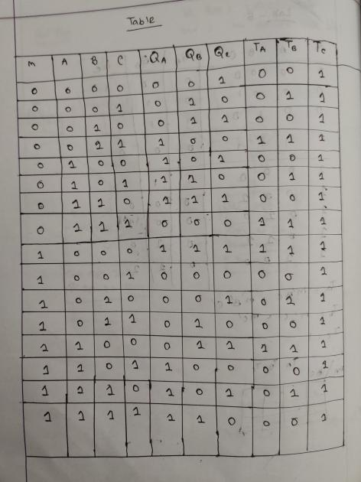

1. Complete K-maps for Ta, Tb, Tc:

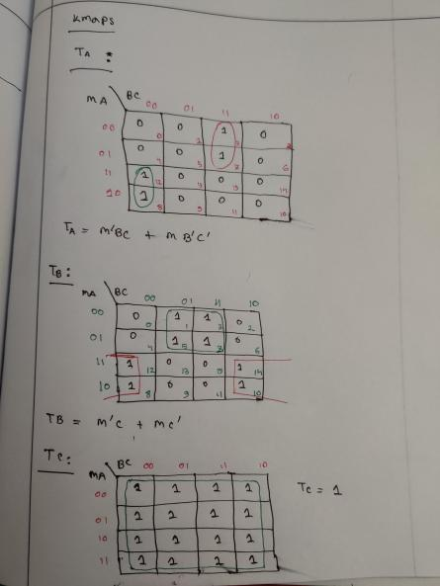

1. Discussion about the topics covered in Lab 5

In the fifth lab class, even though in the manual there was a 4 bit binary up down counter, we were demonstrated how a 3- bit binary up down counter works, it’s detailed truth table where M works as a mode control, A T flip flop was designed using D flip flop, also the design of the circuit. When the input is 0, there is no change in the output of the T flip-flops. It retains the previous value. But when the input is 1, the output is complemented. A XOR gate combined with a D flip-flop can be used to create a T flip-flop. K-maps were used to find the minimized input equations for Ta, Tb, Tc flip flops. The class concluded by instructing us to submit the table, k-maps, discussion in google classroom and the circuit file simulated in Logisim in git.